Neem: The Miracle Tree of Ayurveda — Wellness, Purity, and Protection from The Export Express
Meta Description: Discover Neem’s Ayurvedic power through The Export Express — offering premium Neem capsules, face wash, and cold-pressed Neem oil for skin, health, and holistic wellbeing.

🌿 Introduction: The Green Guardian of Ayurveda
For centuries, Neem (Azadirachta indica) has been revered in Ayurveda as the “Village Pharmacy.” Every part of the tree — from leaves to seeds — offers remarkable healing properties. Known for its antibacterial, antifungal, antiviral, and detoxifying effects, Neem supports everything from skin clarity and immune strength to blood purification and liver health.
At The Export Express, we proudly bring you premium Neem-based products that merge tradition with global standards. From wellness capsules to herbal face cleansers and therapeutic oils, our formulations are designed for health-conscious consumers and international brands seeking high-quality Ayurvedic exports from India.

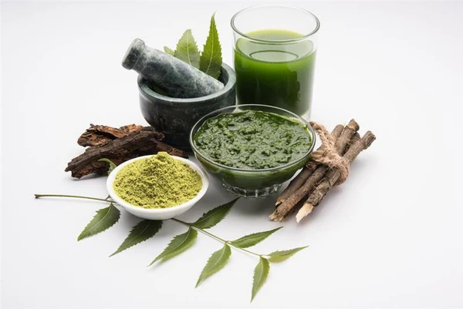
Caption: Neem — India’s ancient detoxifying and protective herb, trusted for centuries in Ayurveda.

🔬 The Science and Tradition of Neem
Neem contains active bio-compounds like azadirachtin, nimbin, and nimbidin, which offer antimicrobial, anti-inflammatory, and antioxidant benefits. These compounds make Neem effective against bacteria, fungi, and viruses, while also supporting internal detoxification and skin purification.
Modern studies validate what Ayurveda has known for millennia — Neem helps maintain healthy skin, supports liver function, and boosts immunity by naturally cleansing the bloodstream.

🌱 The Export Express Neem Product Line

1. Neem Extract Capsules (Ayurvedic Herbal Supplement)
Form: Capsules | Packaging Size: 30 / 60 / 90 Capsules
Shelf Life: 24 Months | Purity: 100% | Country of Origin: India
Our Neem Extract Capsules are made from pure Neem leaf extract (Azadirachta indica), standardized to 3–5% bitters — the active compounds responsible for its powerful therapeutic action.
Key Benefits:
- Supports blood purification and detoxification
- Promotes clear, healthy skin
- Aids liver and digestive function
- Strengthens immunity and metabolism
- Provides antibacterial, antifungal, and antiviral protection
Composition:
- Neem Extract (Azadirachta indica – Leaf)
- Plant-based capsule shell (HPMC)
Dosage Strengths:
- 500 mg per capsule
- 1000 mg per serving (2 × 500 mg capsules)
Suggested Usage:
Take 1–2 capsules twice daily with water or as directed by a healthcare professional.
Certifications:
FSSAI, ISO, GMP, USFDA, HALAL Certified | Lab Tested for Purity & Safety

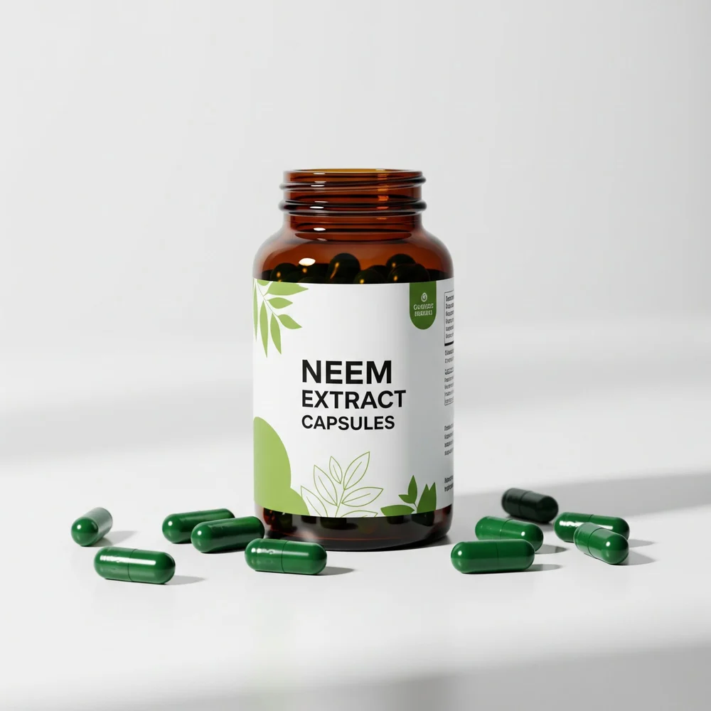
Caption: Neem Extract Capsules from The Export Express — Ayurvedic purity for skin, blood, and immune wellness.

2. Neem Cleanser & Face Wash (Herbal Gel-Based Formula)
Form: Herbal Gel | Packaging Sizes: 100ml / 200ml / 500ml / 1L
Skin Type: For All Skin Types | Shelf Life: 24 Months
Country of Origin: India | Availability: In Stock
The Export Express introduces a Neem Face Wash formulated with a blend of Neem Extract, Tea Tree Oil, Aloe Vera, and Tulsi (Basil Extract). This gentle yet powerful cleanser helps combat acne, cleanse pores, and protect skin from daily environmental stressors.
Key Benefits:
- Deeply cleanses and removes excess oil
- Helps reduce acne and pimples naturally
- Calms redness and irritation
- Keeps skin fresh and balanced
- Suitable for all skin types, especially oily and acne-prone skin
Key Ingredients:
- Neem Extract (Azadirachta indica) – antibacterial & purifying
- Tea Tree Oil – anti-inflammatory & acne control
- Aloe Vera – hydrating & soothing
- Basil Extract (Tulsi) – antioxidant & skin clarifier
Ideal For:
Natural skincare brands and wellness enthusiasts seeking Ayurvedic-grade herbal cleansers.

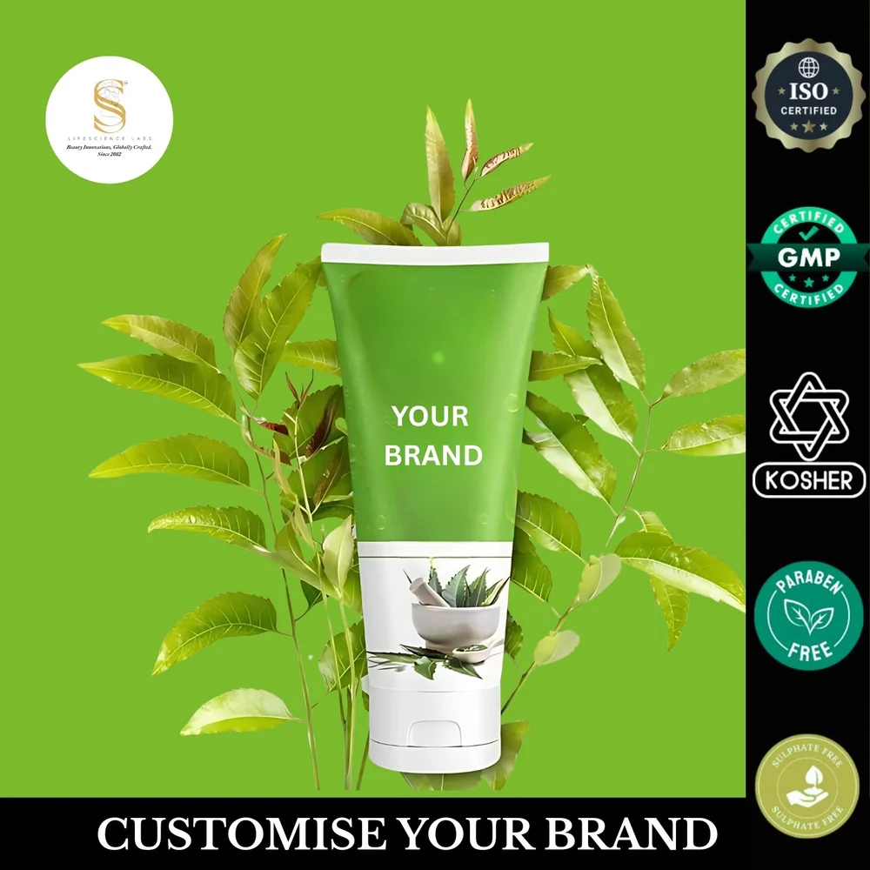
Caption: The Export Express Neem Face Wash — gentle, effective, and designed for natural skin care routines.

3. Cold Pressed Neem Oil (Therapeutic & Cosmetic Grade)
Form: Oil | Packaging Sizes: 1L / 25L / 50L / 200L
Extraction Method: Cold Pressed | Purity: 99% | Shelf Life: 24 Months
Color & Odor: Dark green to brownish; earthy aroma
The Export Express offers Cold Pressed Neem Oil — a 100% pure and natural extract derived from Neem seeds and kernels using the cold press method. This ensures maximum retention of essential compounds like azadirachtin, nimbidin, and fatty acids.
Technical Specifications:
Parameter | Value
Specific Gravity | 0.910 – 0.930 at 25°C
Flash Point | >220°C
pH Value | 4.5 – 6.5
Extraction | Steam Distillation / Cold Press
Grade | Therapeutic / Cosmetic / Pharmaceutical
Odor | Strong, earthy, natural Neem aroma
Applications:
- Aromatherapy and massage oils
- Skincare & haircare formulations
- Pharmaceutical and cosmetic products
- Natural pesticide and disinfectant
Benefits:
- Moisturizes and soothes dry skin
- Reduces dandruff and scalp irritation
- Supports acne and eczema care
- Used in spa and wellness blends for detox and relaxation

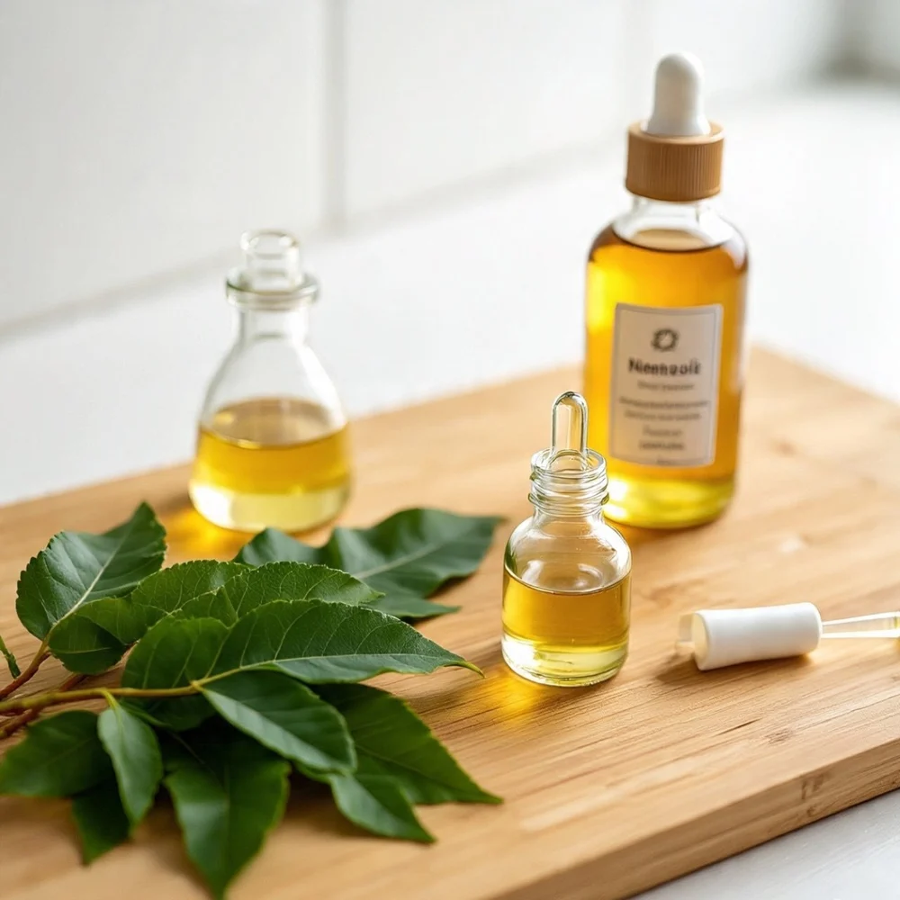
Caption: The Export Express Cold Pressed Neem Oil — pure, nutrient-rich, and ideal for skincare, aromatherapy, and wellness.

🌿 How Neem Enhances Health & Wellness

1. Detoxification & Blood Purification
Neem cleanses the blood and eliminates toxins, promoting internal clarity and healthy skin.

2. Immunity & Defense
Rich in antioxidants and natural compounds, Neem strengthens immunity and defends against bacterial, fungal, and viral infections.

3. Liver & Digestive Health
Neem supports bile production, aiding liver detoxification and smooth digestion.

4. Skin & Hair Health
Its antibacterial and antifungal properties make it ideal for acne, dandruff, and pigmentation issues.

5. Natural Pest & Germ Control
Neem oil serves as an eco-friendly disinfectant and insect repellent — safe for home, agricultural, and spa use.

🧴 Why Choose The Export Express for Neem Products?
- Authentic sourcing from India’s finest Neem plantations
- Cold-pressed and lab-tested for purity
- Private labeling and OEM manufacturing options
- FSSAI, ISO, GMP, and USFDA certifications
- Eco-conscious, cruelty-free, and vegan-friendly formulations
- Global distribution network with export-ready logistics
Whether you’re a wellness brand, distributor, or retailer, The Export Express offers customized Neem product solutions crafted to meet international standards and client requirements.

🔗 Suggested Internal Links
- Explore More Herbal Extracts from India
- Shop Neem Products Online
- Learn About Ayurvedic Ingredients
- Private Label & OEM Services
- Contact Us for Bulk Orders

🌏 Conclusion: Nature’s Green Protector, Perfected by The Export Express
From immunity and detoxification to skincare and wellness, Neem remains one of Ayurveda’s most versatile gifts. The Export Express continues this legacy with premium-quality Neem products — scientifically crafted, ethically sourced, and globally trusted.
Choose purity, sustainability, and the power of nature — choose The Export Express Neem Range.

Keywords: Herbal export India, Neem exporter, Neem oil supplier India, Neem capsules exporter, Ayurvedic skincare export, Neem face wash manufacturer.

